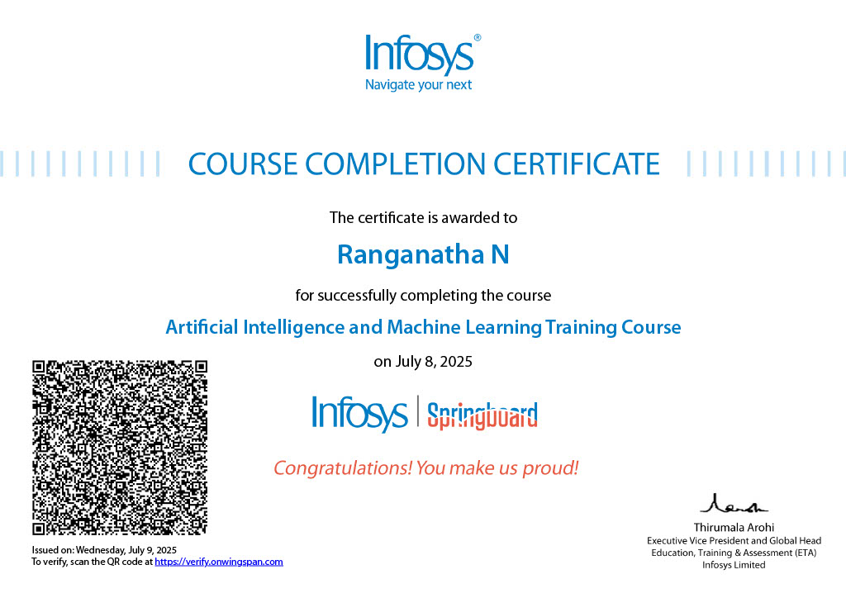

About this course:

Machine Learning (ML) is one of the key tenets in the field of Artificial Intelligence. Organizations such as Google, Facebook, Uber, Netflix, etc. have been leveraging machine learning to provide improved and engaging experiences to their consumers.

Although various machine learning techniques have been conceptualized and are in use for several decades now, the current demand for ML is fueled by the high availability of data and resources for computing this data. This technique is being deployed by industry for business benefits.

This course serves as an introduction to various ML concepts such as Regression, Classification, Clustering and Neural Networks. At the end of this course, you should be familiar with the key ideas powering these concepts and also develop programs (in Python), that use them

Concepts you must know before doing this course:

* Generic overview of Artificial Intelligence (AI).
* Basic knowledge of  Python programming language.
* Hands-on experience in Data Science related Python libraries such as numpy, pandas, and matplotlib.

Software Requirements For This Course:

* Anaconda distribution of Python 3.5 or above

Learning Outcomes:

* Identify the type of machine learning problem for a given use case.
* Apply Classification, Regression and Clustering algorithms to various problems using Python.
* Explore various validation techniques for machine learning models.
* Understand what is Artificial Neural Networks (ANN).

## ai & ml.jpg

## What Is Artificial Intelligence And Machine Learning

Artifical Inteligence:

Artificial Intelligence is the field of developing computers and robots that are capable of behaving in ways that both mimic and go beyond human capabilities. AI-enabled programs can analyze and contextualize data to provide information or automatically trigger actions without human interference.

Today, artificial intelligence is at the heart of many technologies we use, including smart devices and voice assistants for example such as Siri on Apple devices.

Machine Learning:

Machine learning is a pathway to artificial intelligence. This subcategory of AI uses algorithms to automatically learn insights and recognize patterns from data, applying that learning to make increasingly better decisions.

By studying and experimenting with machine learning, programmers test the limits of how much they can improve the perception, cognition, and action of a computer system.

Deep learning, an advanced method of machine learning, goes a step further. Deep learning models use large neural networks — networks that function like a human brain to logically analyze data — to learn complex patterns and make predictions independent of human input.

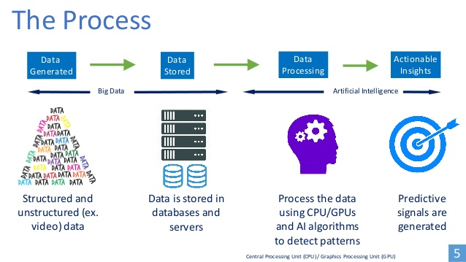How AI Process Works ?

Artificial Intelligence (AI) works by simulating human intelligence through the use of algorithms, data, and computational power. The goal is to enable machines or software to perform tasks that typically require human intelligence, such as learning, reasoning, problem-solving, perception, and language understanding.

Machine Learning Process ?

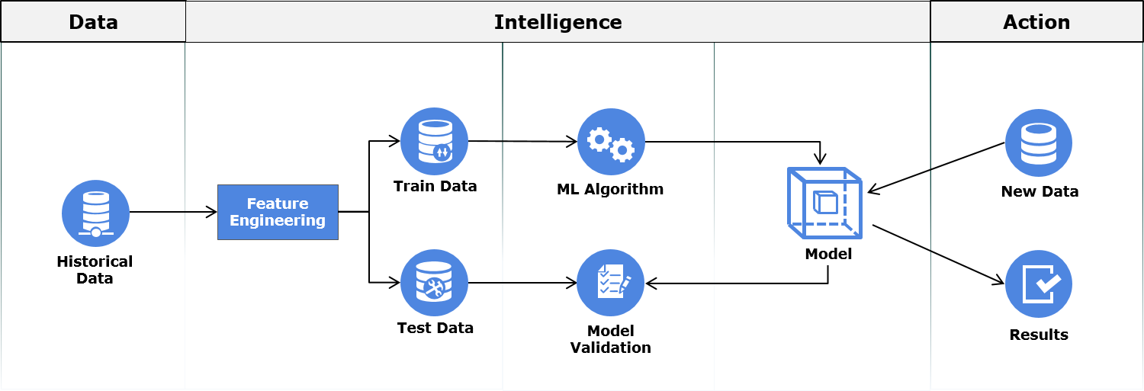In this process, first relevant data is gathered then is cleaned and transformed through a process called Feature Engineering. During the process of Feature Engineering, handling missing value, handling outliers, creating new features out of existing ones are some of the common tasks performed.

After feature engineering, the data is split into Train Data and Test Data. The Train Data is used for training the machine learning model. Once the model is built, it is validated against the Test Data for accuracy. This accuracy helps us in estimating the performance on previously unseen data. If the model performance on both Train and Test Data is satisfactory, the model may be deployed.

Once deployed, the model makes predictions on new data ; these predictions/insights are used to take business decisions.